Gametel Gaming Controller Turns Your Android Handset Into an Xperia Play
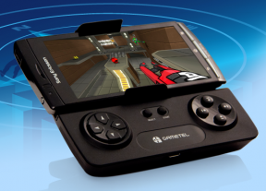
The Xperia Play for manyof us wasn’t a device that we would swap our PSP or Nintendo DS for, with a limited number of PSX games available for the Android handset it was a bit of a fail on most accounts.
It didn’t have a duel-core processor that was becoming the standard to meet, and it didn’t come with the clever Bravia engine that the Xperia Ark had. So it was relying soley on being a pure gaming handset.
Shelling out over £300 for the device is not something I would of don but this is where Fluctel’s Gametel Gaming Controller comes into it — a bluetooth controller that latches on to any Android phone that runs Android 2.1 or higher. Oh, and did I mention that it’ll support over 50 games straight out of the box, including Cordy, Asphalt 5 HD, Reckless Getaway, Guns’n’Glory, MotoX Mayhem, Happy Vikings and Zenonia.
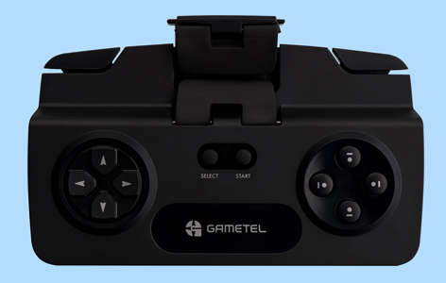
According to PocketGamer, the Gametel Gaming Controller offers about nine hours of battery life and automatically shuts down after six minutes of inactivity. The controller connects to the phone via Bluetooth, which means that you can also disconnect the controller and play from afar. A handful of powerful Android devices sport kickstands these days so that’s an option, but if your phone supports HDMI out then you’re in for a real treat. No console, no expensive games — just you, your phone, and the gaming controller duking it out on the big screen.
The controller sports spring-loaded clamps and rubberized grips to lock your phone into place, but that surely can’t protect against gamer rage, so no throwing this controller across the room, OK?
The truth is, no matter how excellent your phone’s graphics are or how fast your processor is, some games are just annoying using on-screen controls. That’s why the Xperia Play was such a brilliant idea, and why the Gametel Gaming Controller is an even better one.
The controller isn’t available yet, but the company has an email notification sign-up on its website. The controller will retail for around £49.95 (US $67), and should show its D-Padded face in December.

